Google Webmaster cannot verify my Wix site:

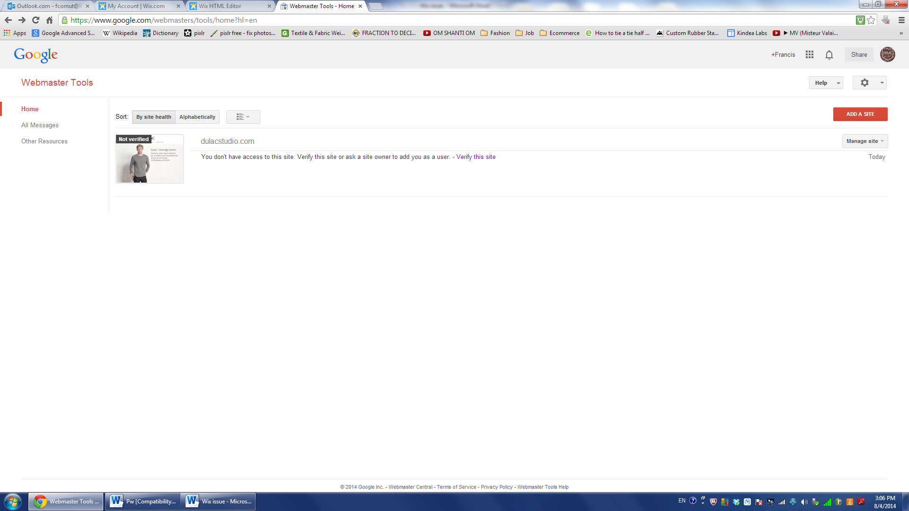

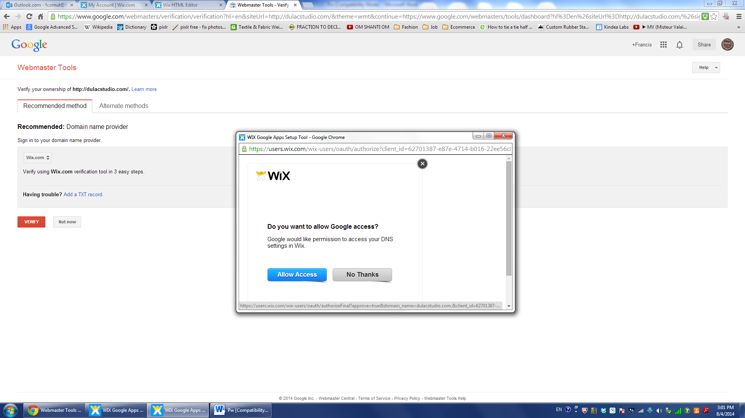

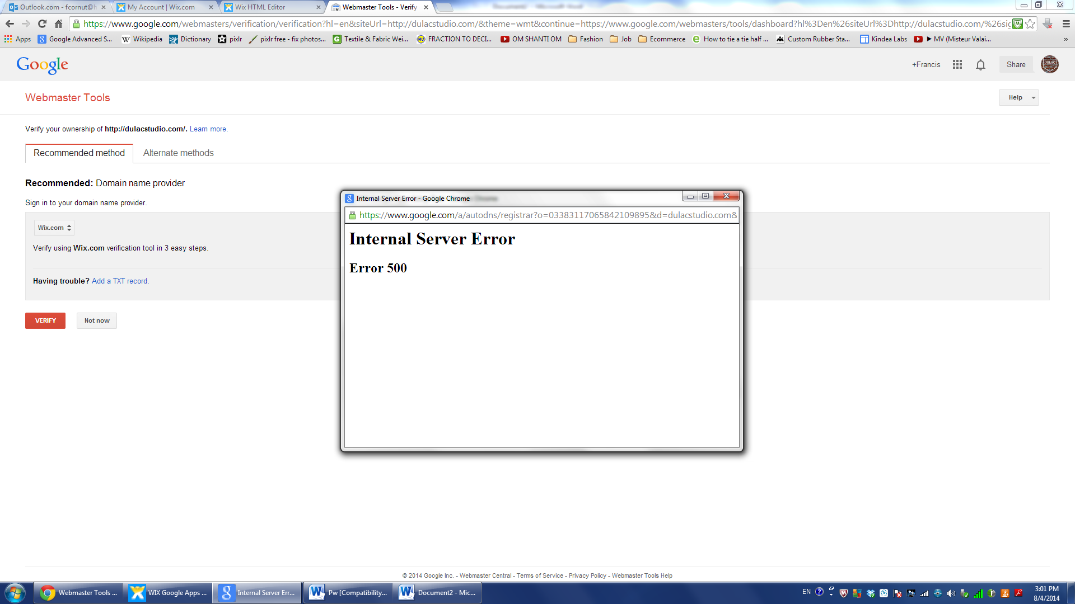

<meta name="google-site-verification" content="dk2uBMDMKMfW6MgQerbQvl7jIz46WNa7IEw9GrnBJHA" />

